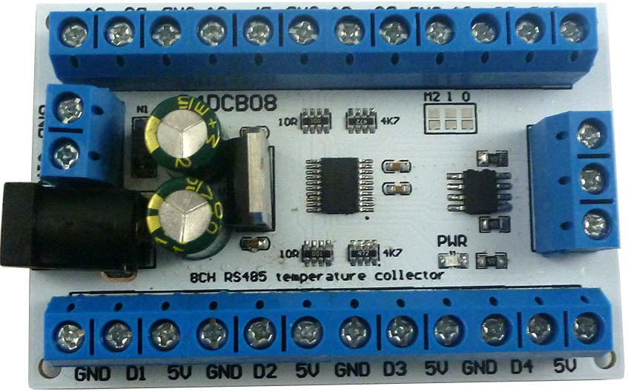**Features:**

1: Operating Voltage : DC 6-24V(DC 9V 12V 15V 24V)

2: Operating Current :8-13MA(It is related to the number of external DS18B20)

3: MODBUS RTU Command support 03 06 function code

4Temperature sensor is DS18B20, Up to 8 DS18B20 temperature sensors can be connected at the same time

5 Measures Temperatures from -55°C to +125°C(-67°F to +257°F)

±0.5°C Accuracy from -10°C to +85°C

6 :MODBUS commands can be made serial HyperTerminal (serial assistant) OR PLC Enter;

7 :Under the MODBUS command mode, it can support up to 247 devices in parallel

8 :Size: 70 * 46 * 18mm

9 :Weight: 40 g

Modbus RTU Command Please refer to : "R4DCB08 modbus rtu protocol"

**Wiring diagram:**

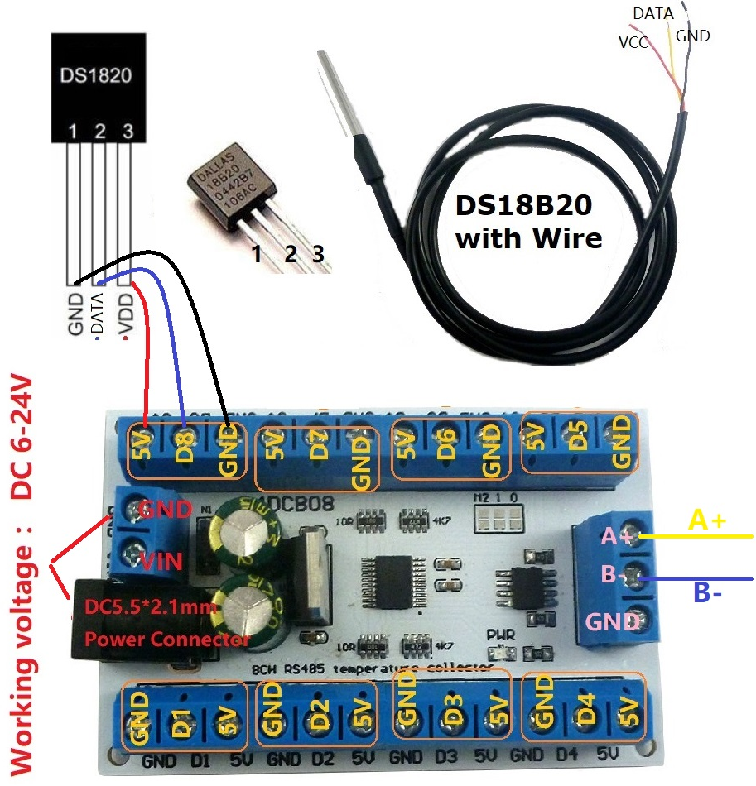

Slave ID: Different "Sliver ID" can be set by command, the maximum number is 247

Under the MODBUS command mode,the slave ID must be correct

Command Description, Please refer to " R4DCB08 modbus rtu protocol "

